## **Question 1:**

## 

## Go to the ADF studio and create your first pipeline name: Copy_ProductTable_To_CSV.

## In the newly created SQL DB there is one built in SalesLt.Product table.

## Copy the Product table data to CSV file in 'landing/CSV' folder in ADLS using the ADF.

**Solution:-**Create AZURE SQL DB then create LinkedService for source i.e Azure Sql Database.

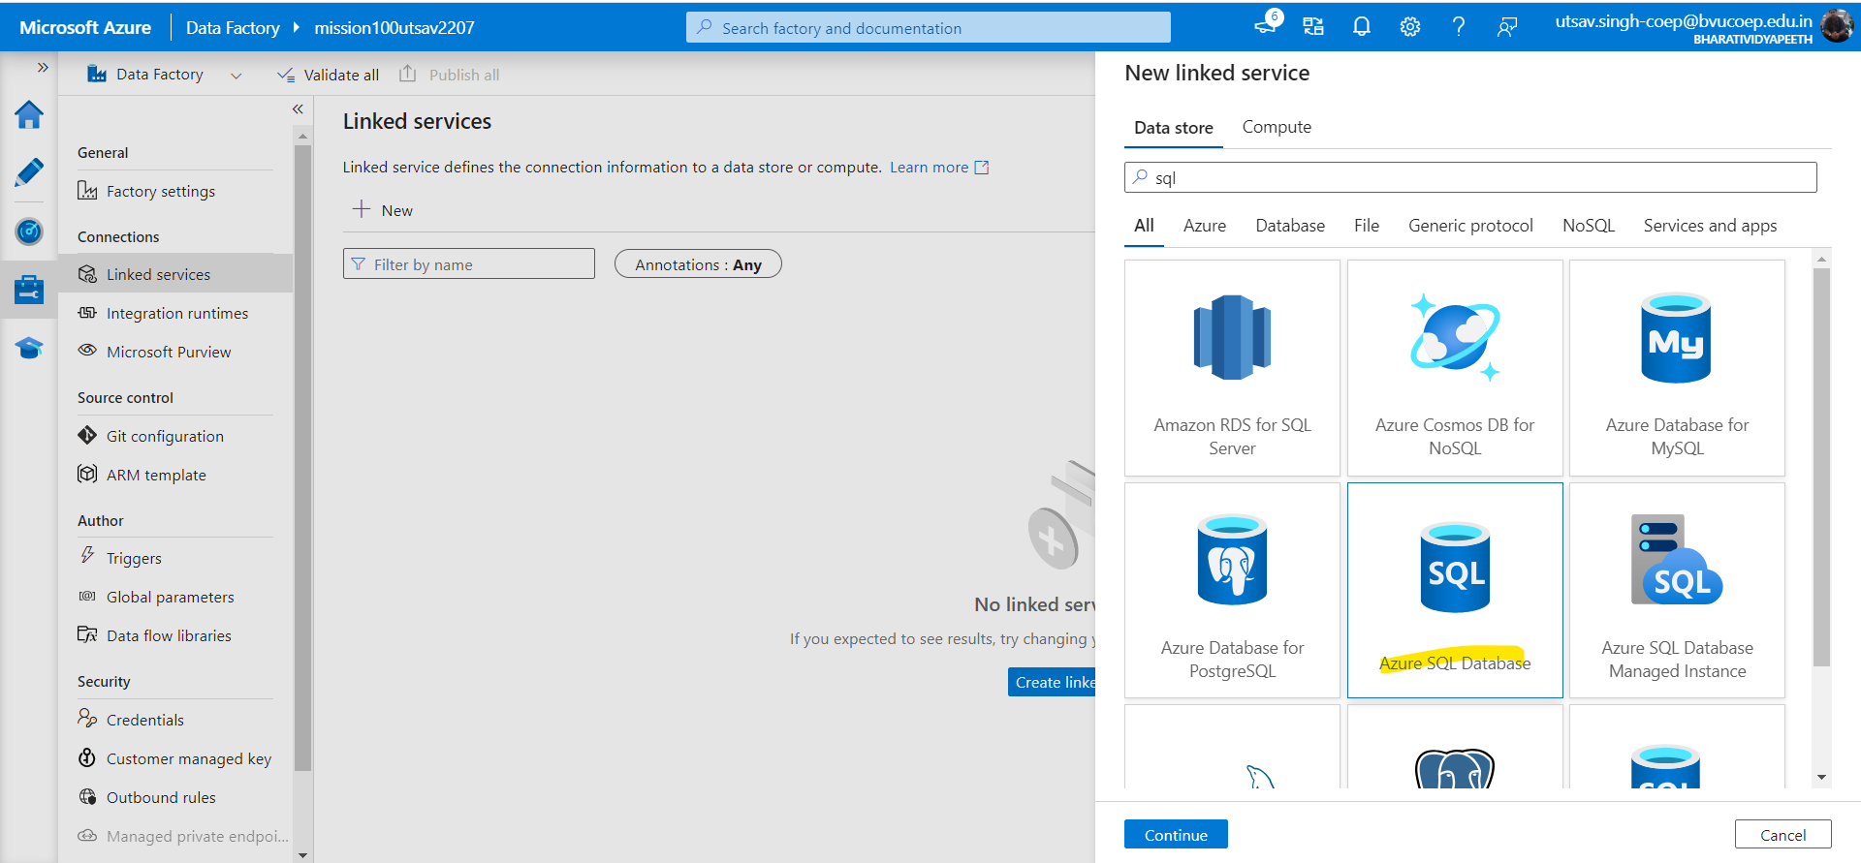

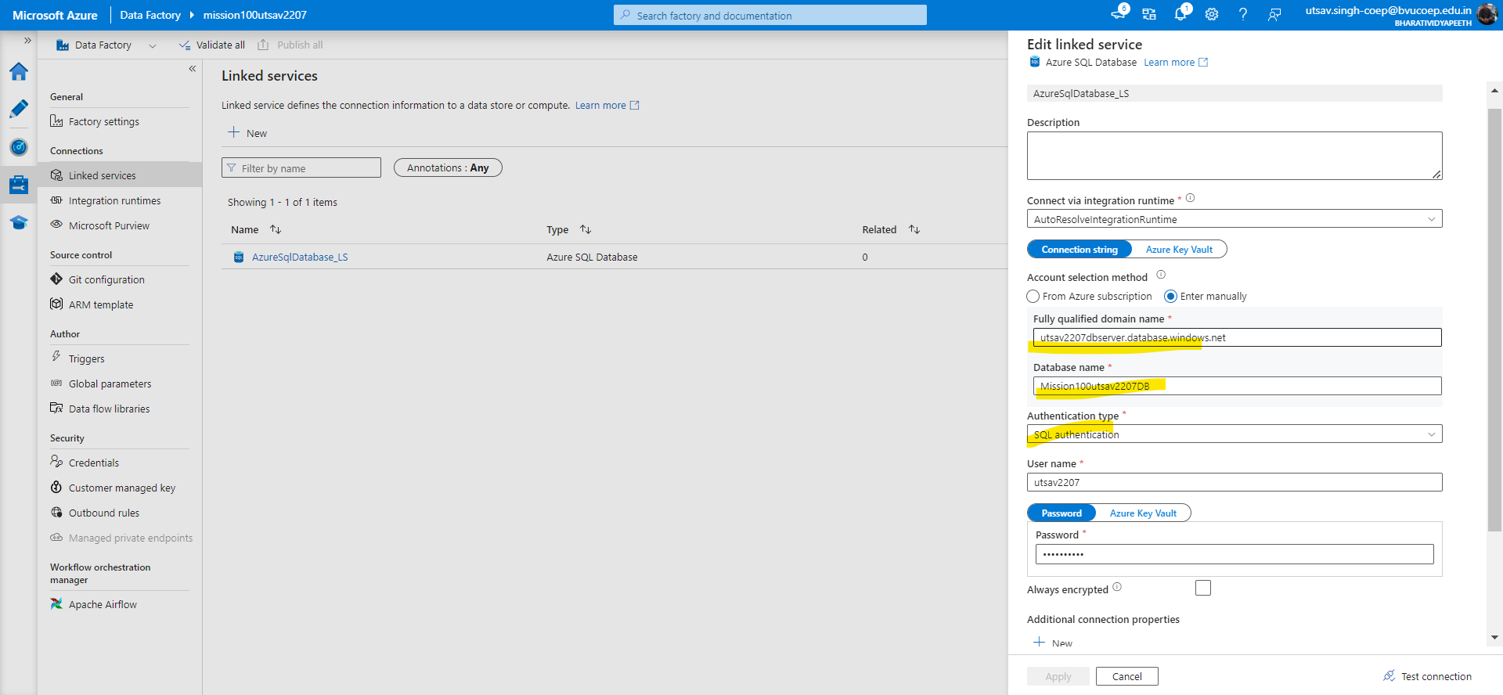

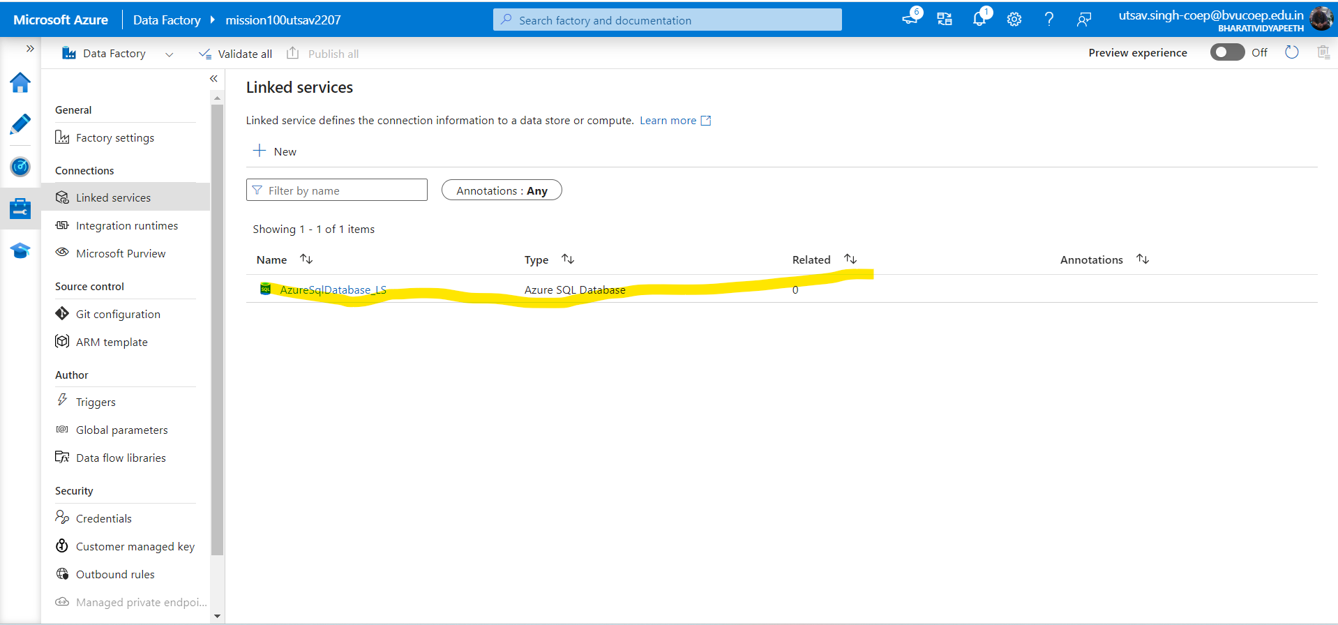

-Create a 2nd Linked Service for the destination(where you want the data)

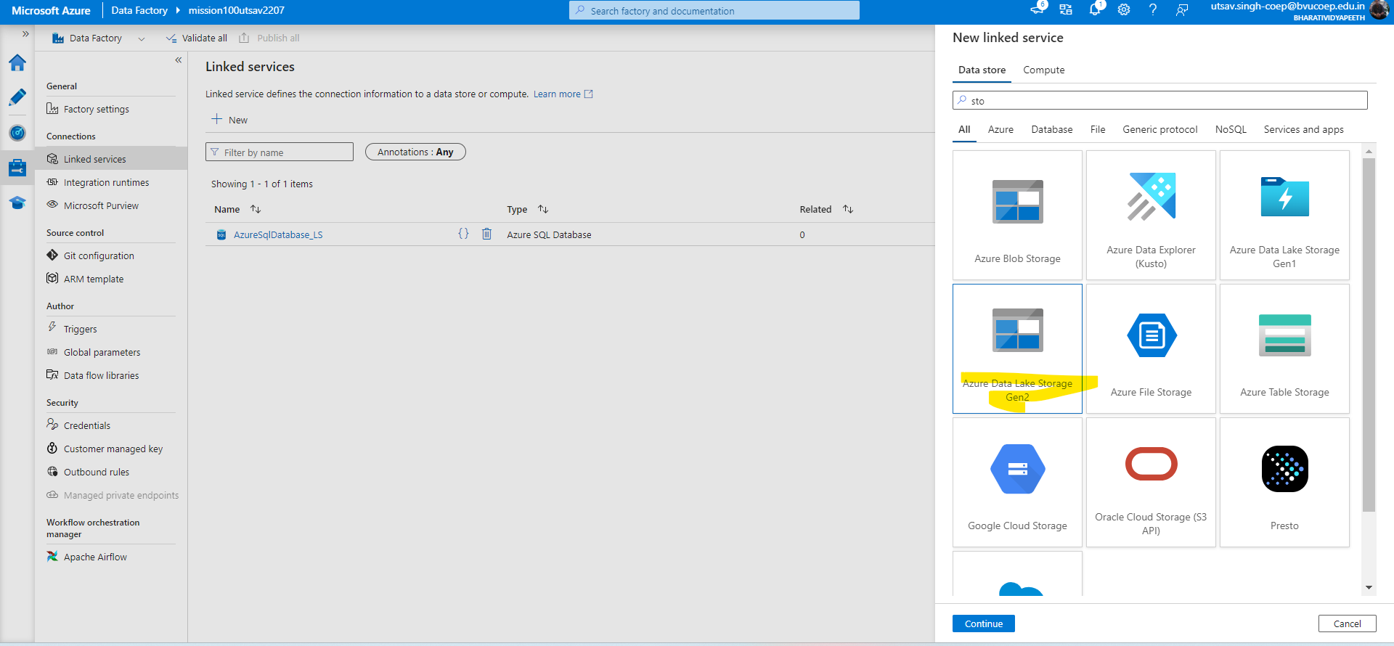

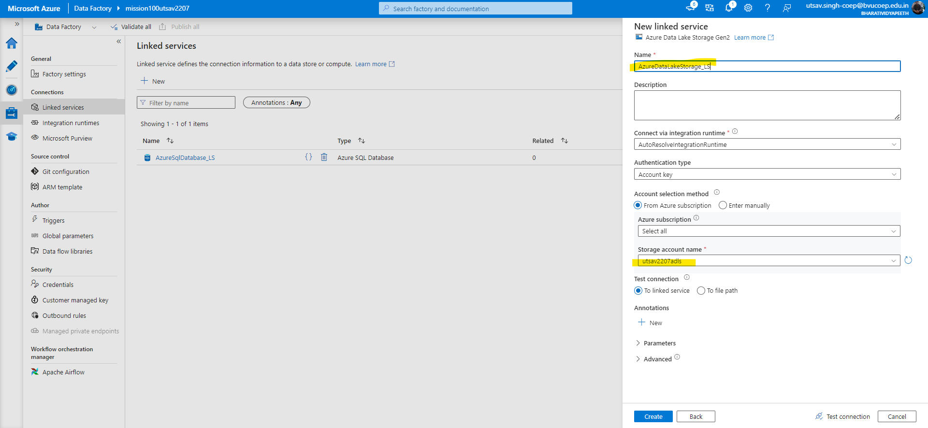

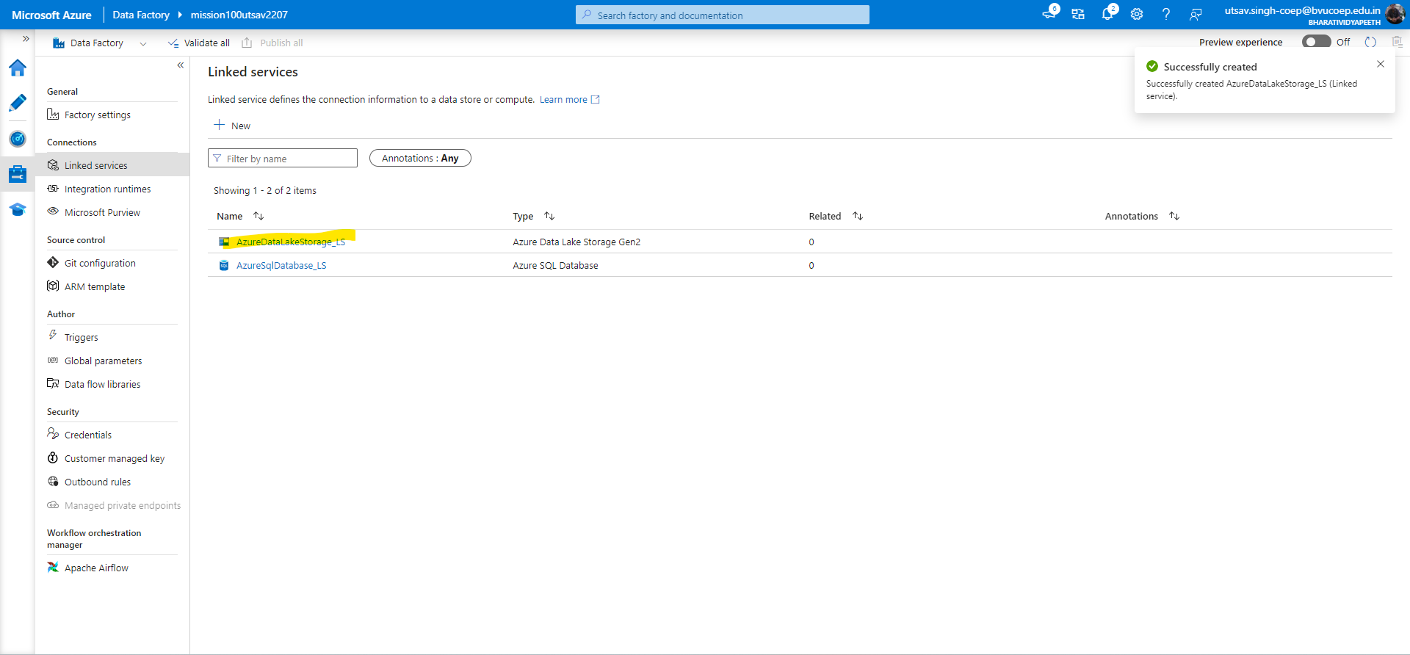

-Now create Source Dataset in ADF

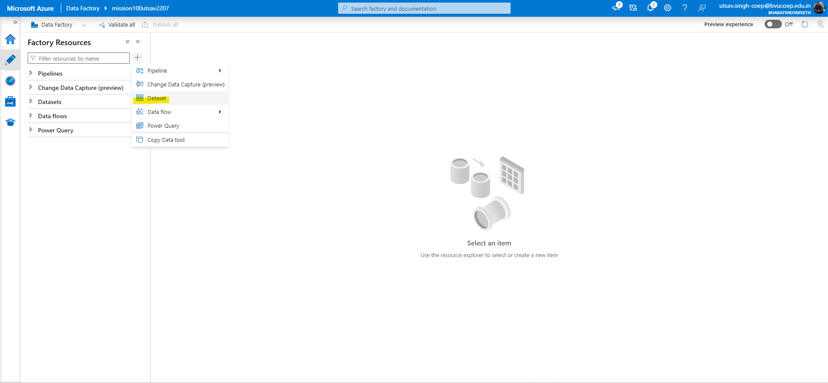

-After clicking DATASET choose Azure SQL DB

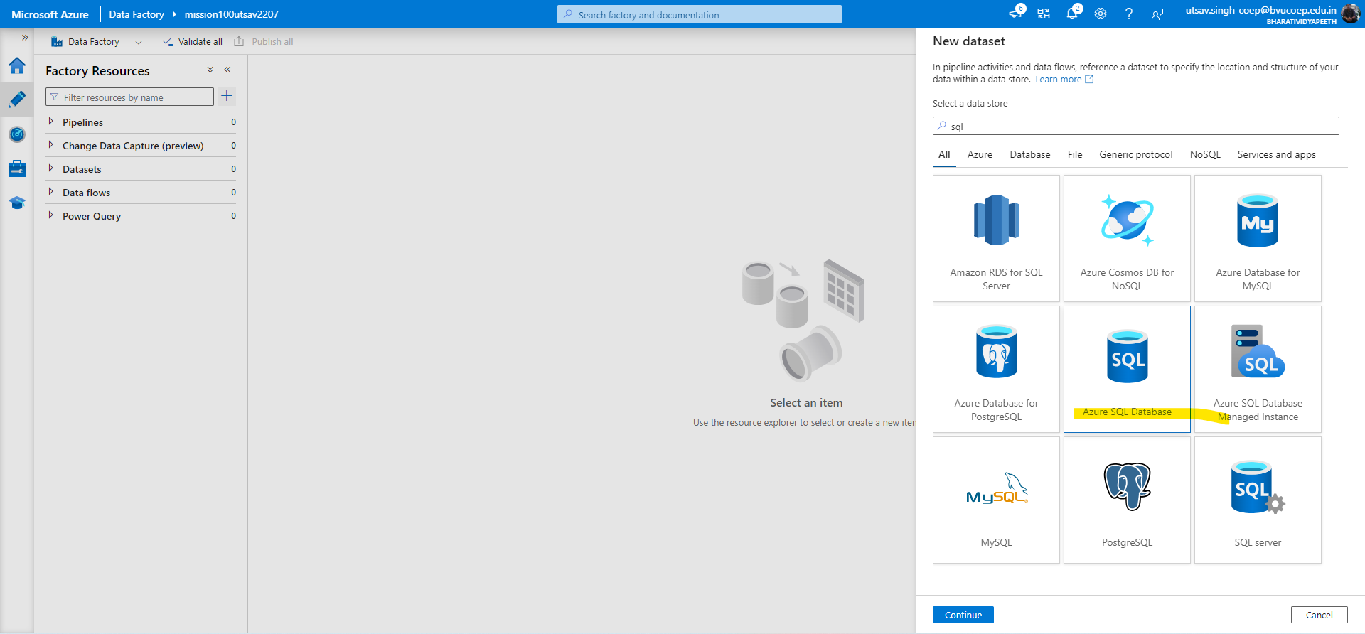

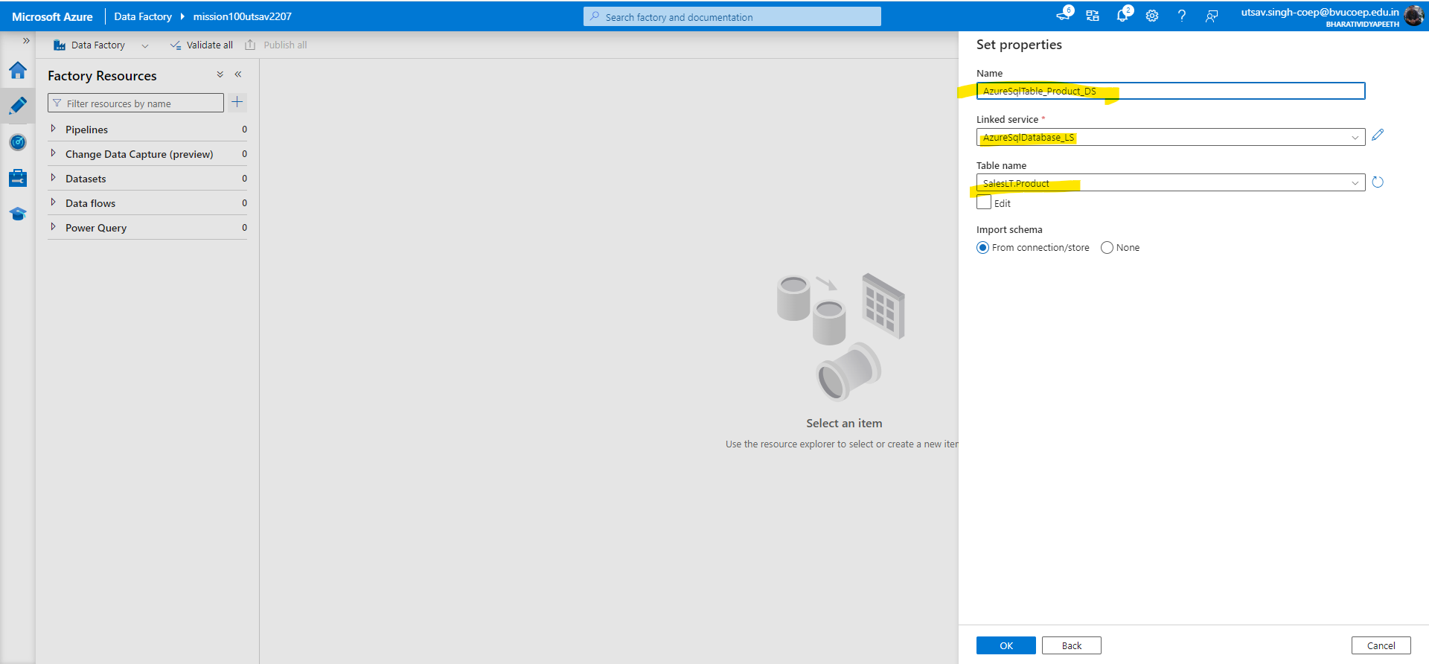

-Dataset will be created for specific Product table

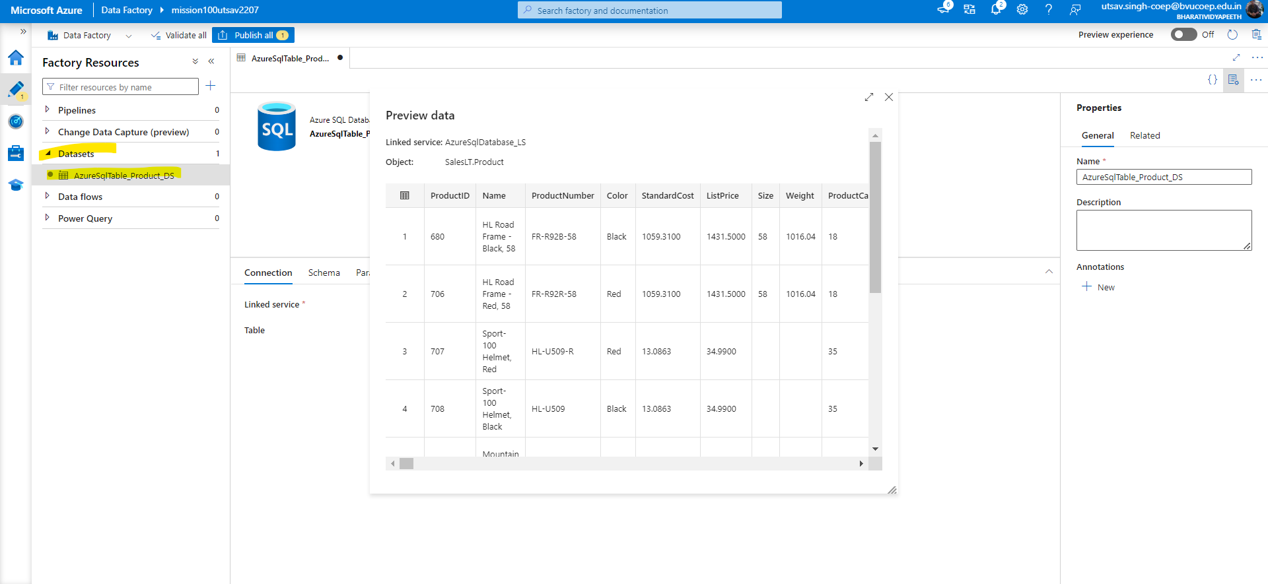

-Now Create new Dataset for Destination i.e ADLS

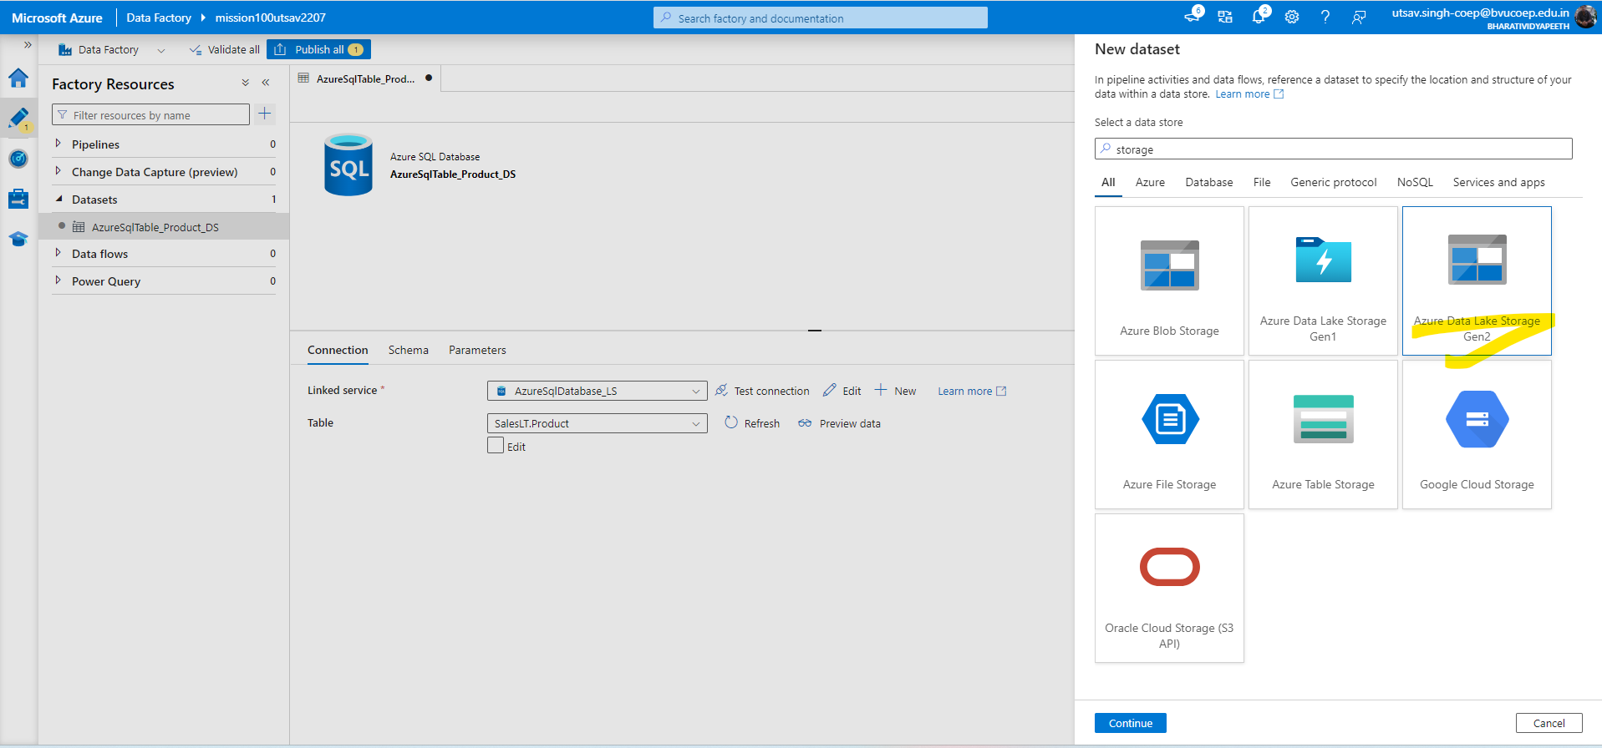

-Now Select format i.e CSV

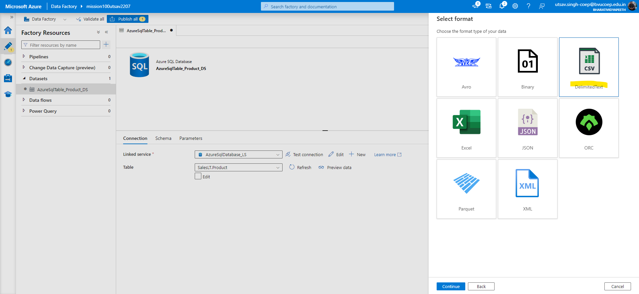

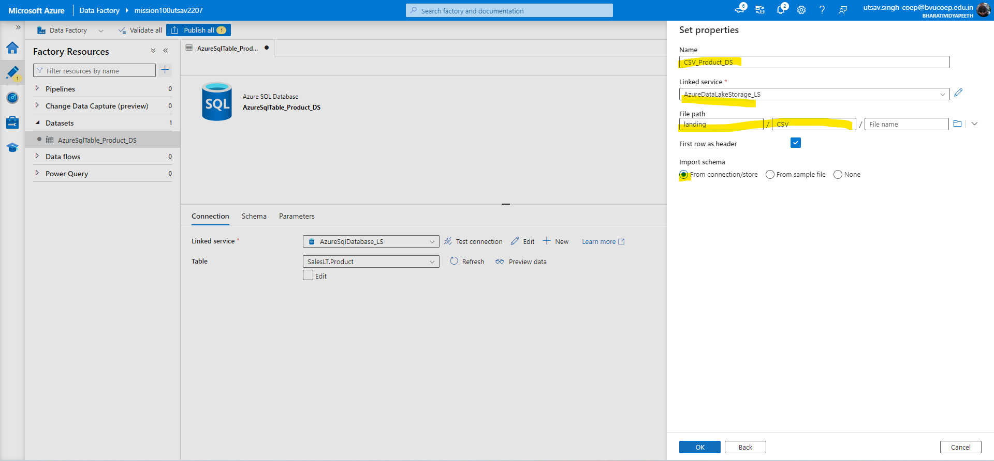

-Now Create a new Pipeline

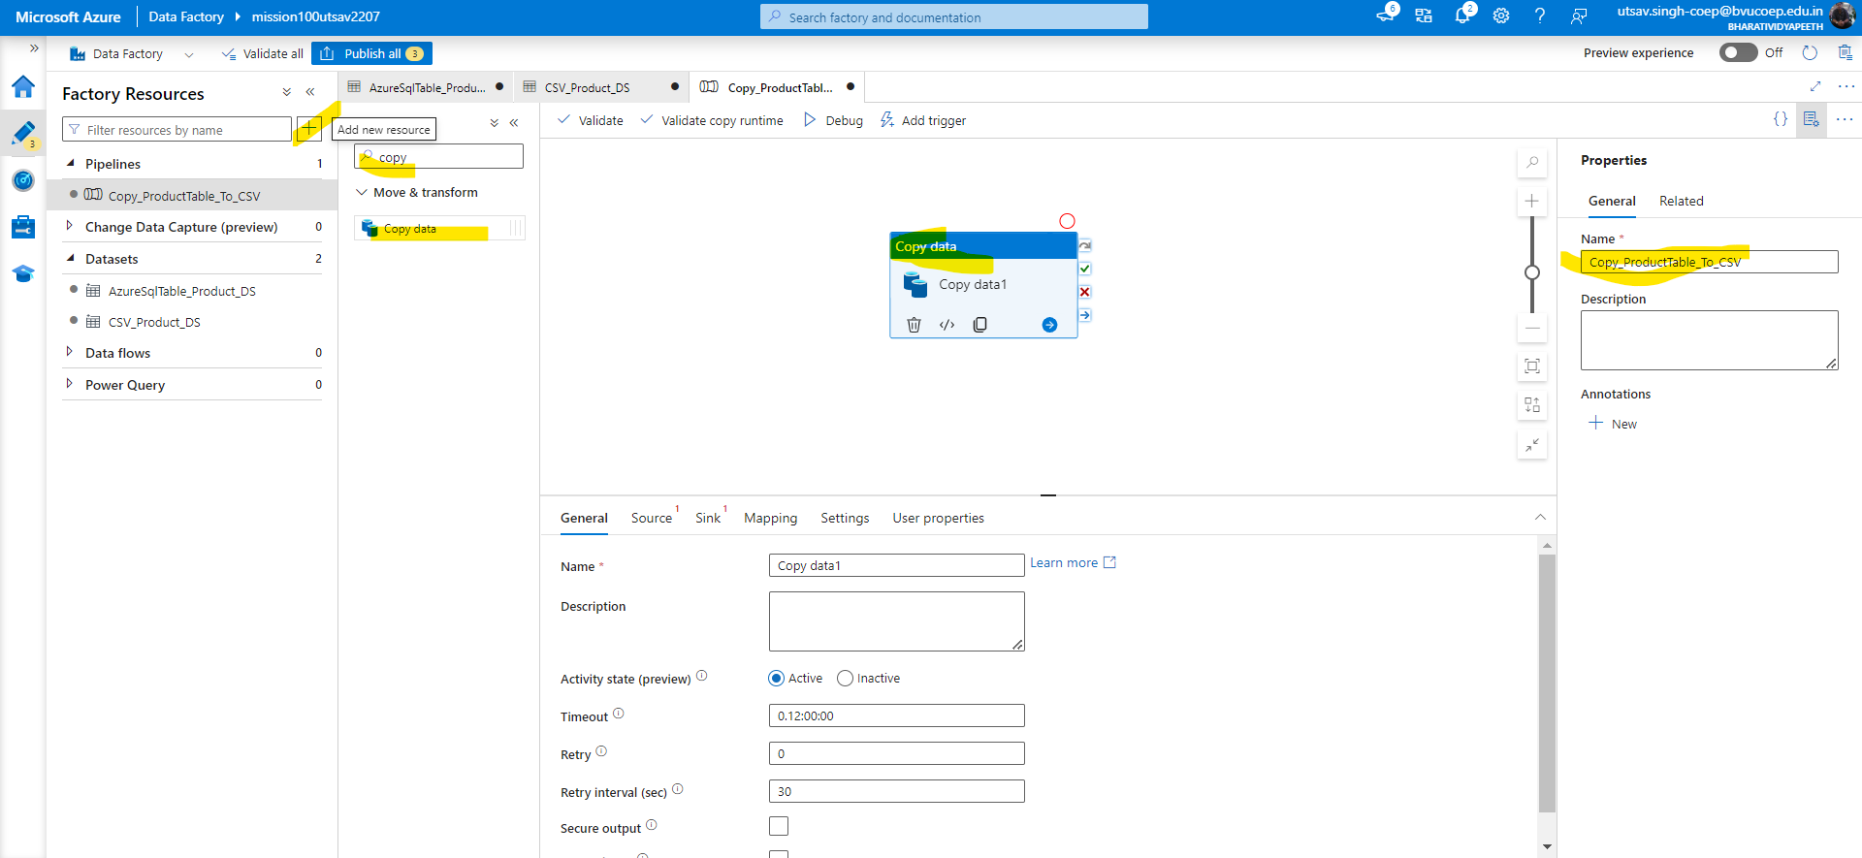

-Choose source & Sink for Data flow source to destination.

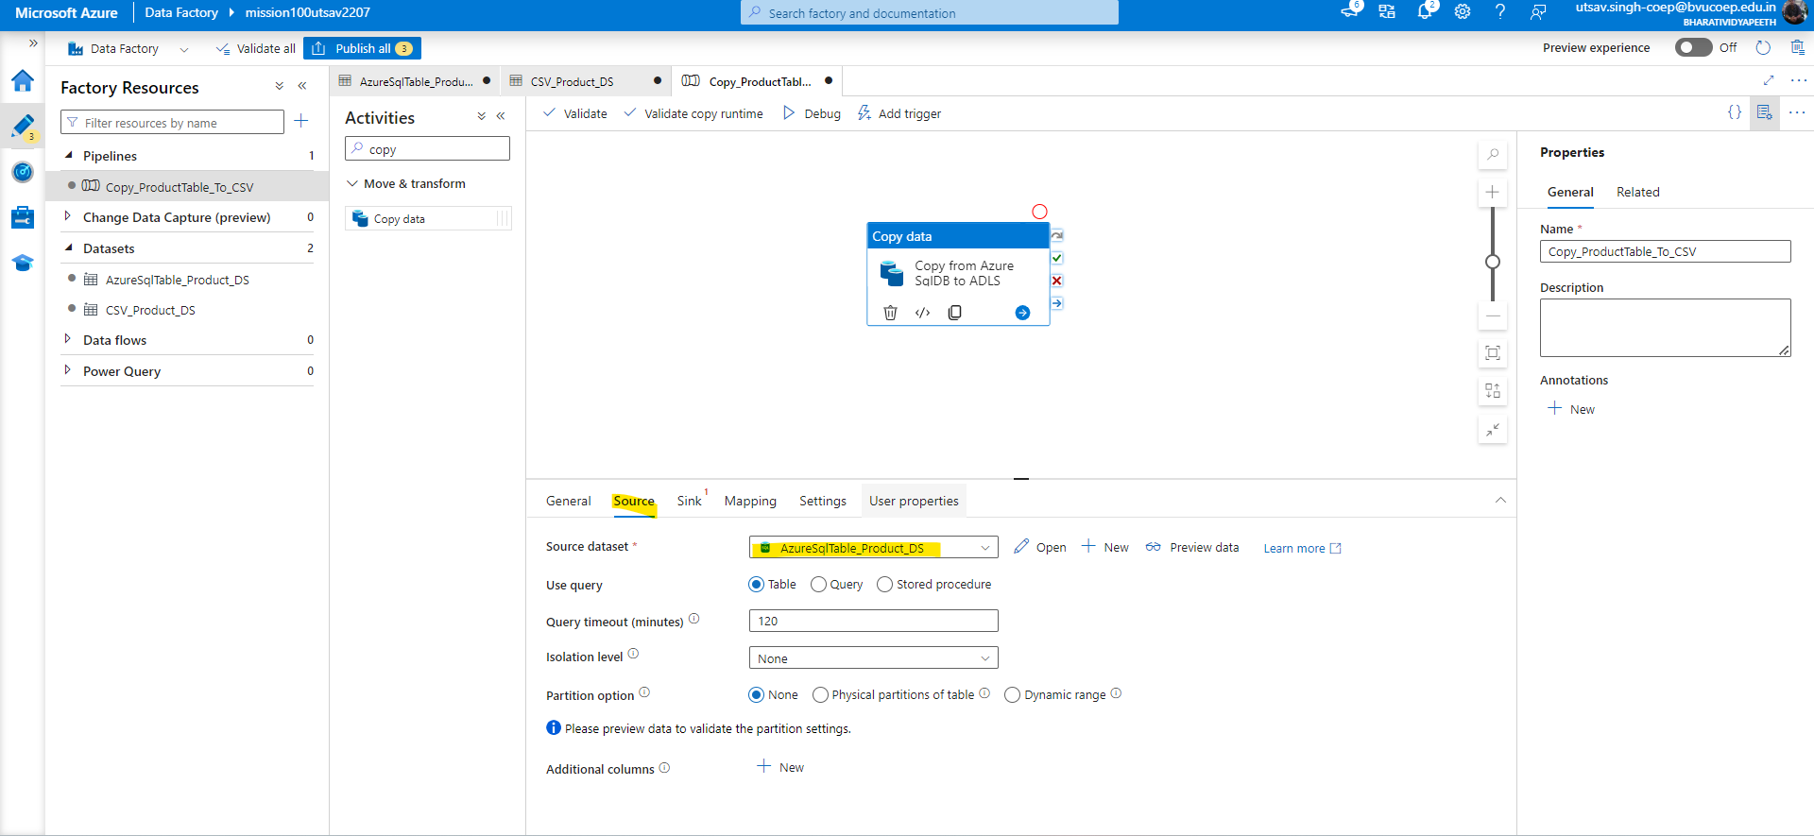

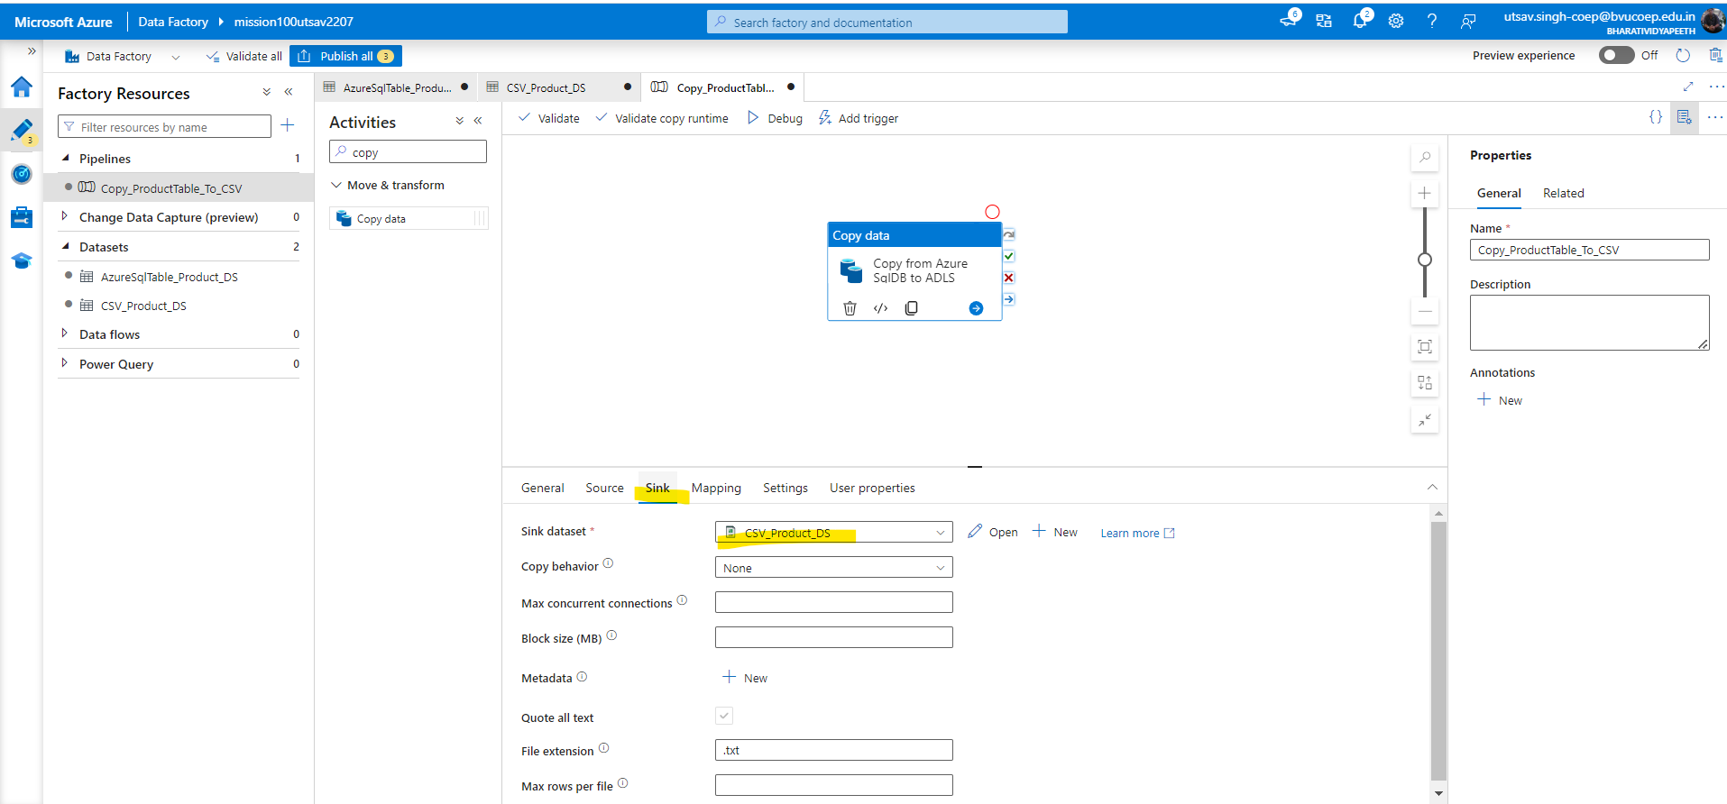

-Then Click on debug to run the Pipeline

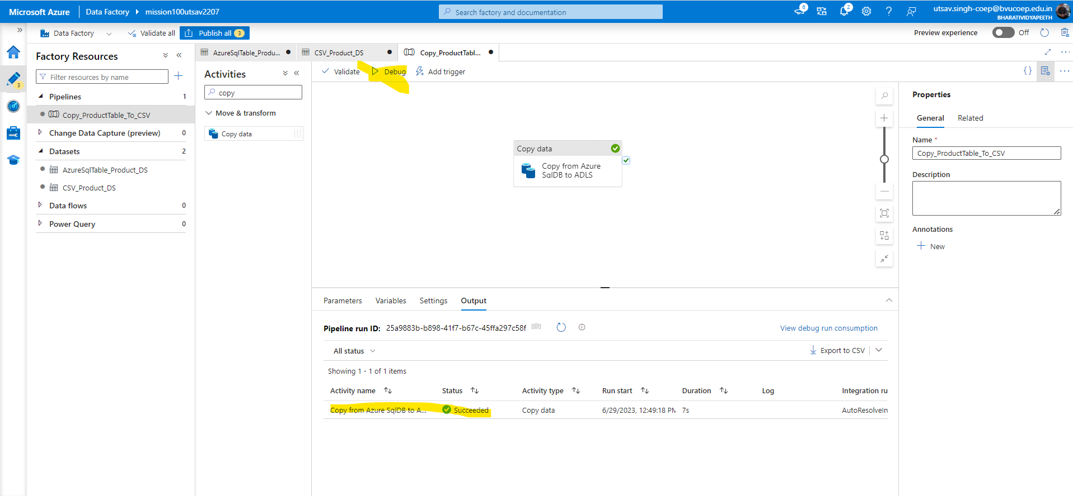

-Finally when you check in ADLS path then fetched data will be shown in the destination which is ADLS

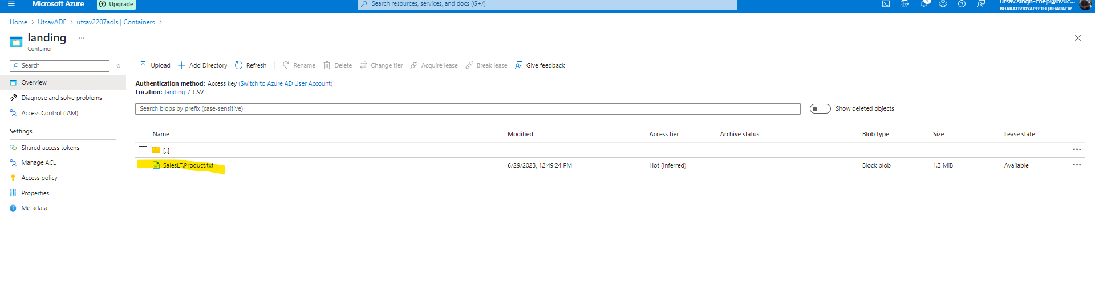

## **Question 2**:

## Create another pipeline name: Copy_Customer_To_JSON In the newly created SQL DB there is one built in SalesLt.Customer table.

## Copy the Customer table data to JSON file in 'landing/JSON' folder in ADLS using the ADF.

## 

## Hint: During the dataset creation step instead of choosing the file type CSV choose JSON

**Solution:-**

1.Create Linked List(Contains Connection information) first I already created Source and Destination Linked List.

2.Create Source and Destination Dataset

-Create Azure SQL DB FOR SOURCE DATA

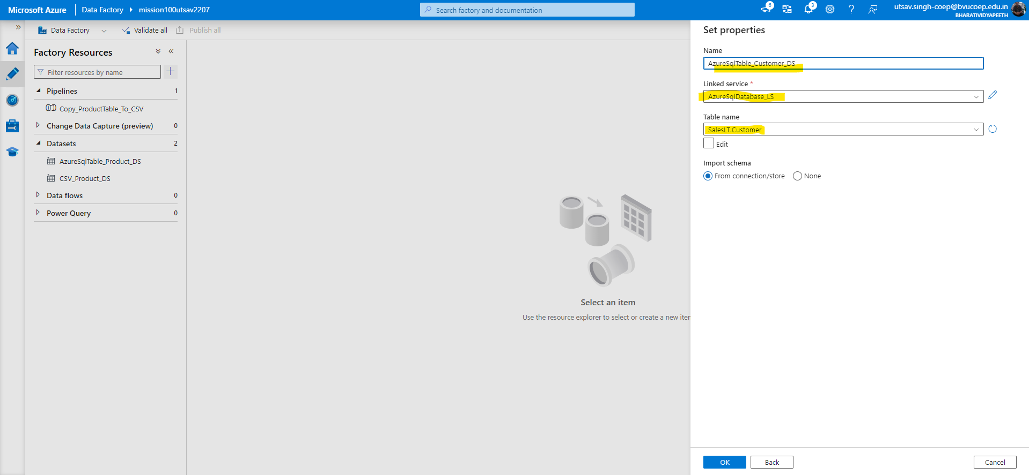

-Create Dataset for ADLS destination in JSON format

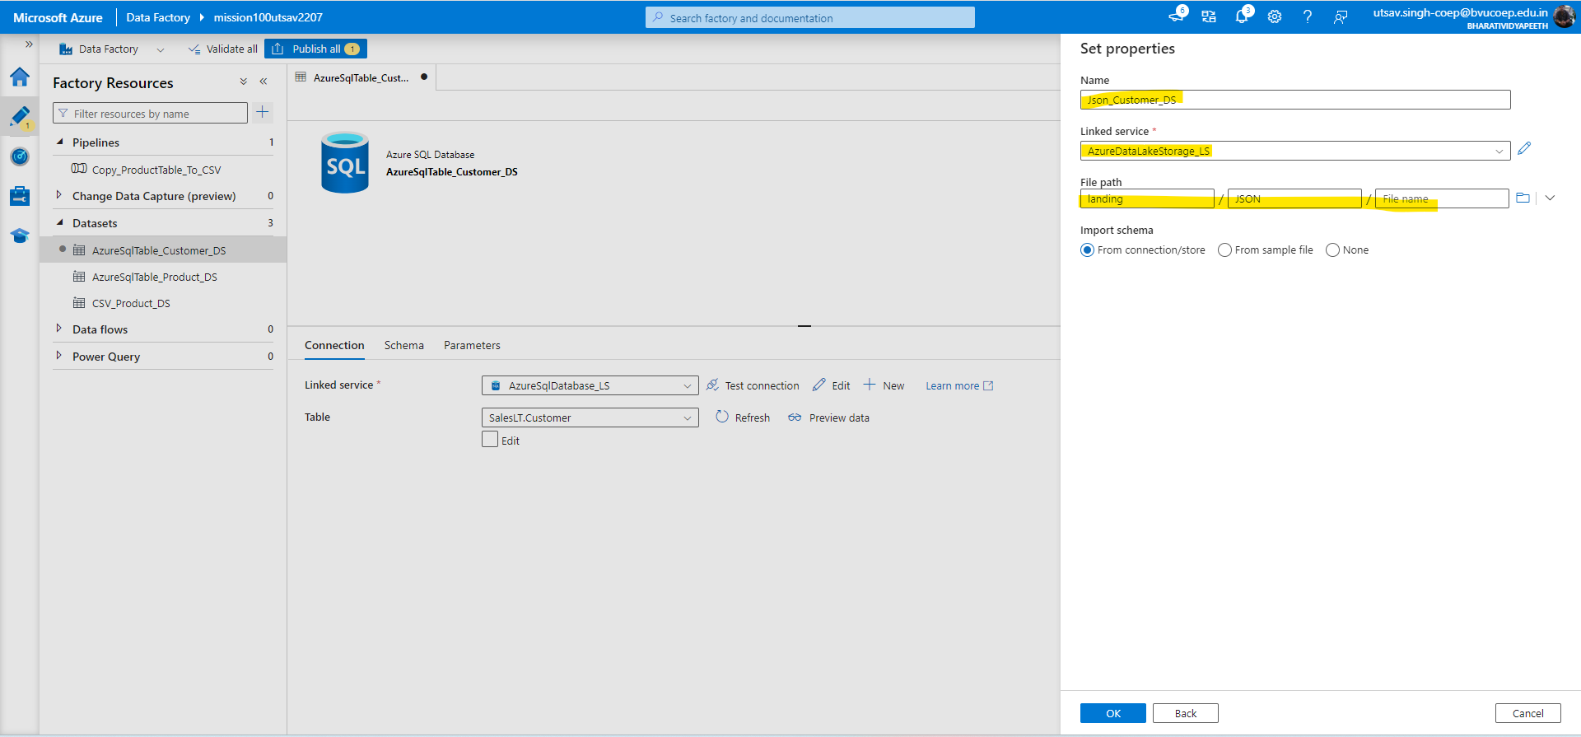

3. Create a new copy activity Pipeline

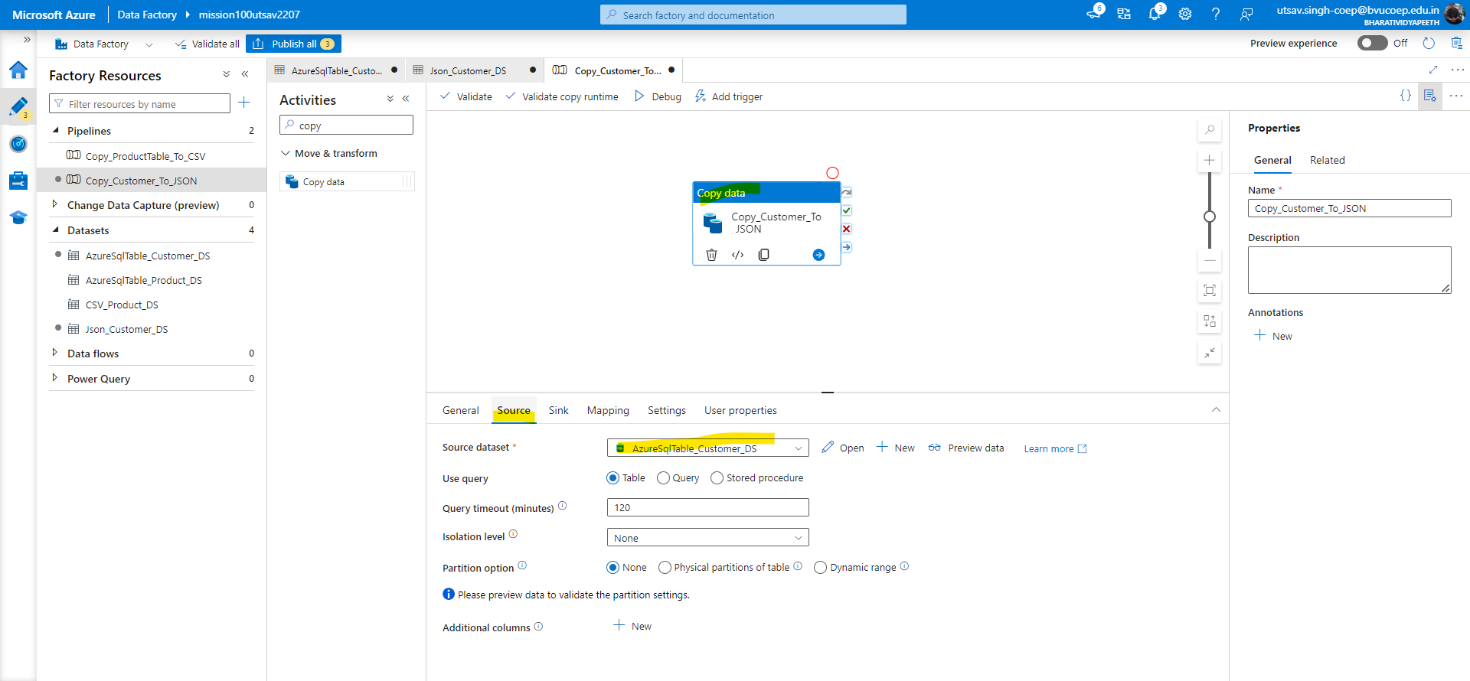

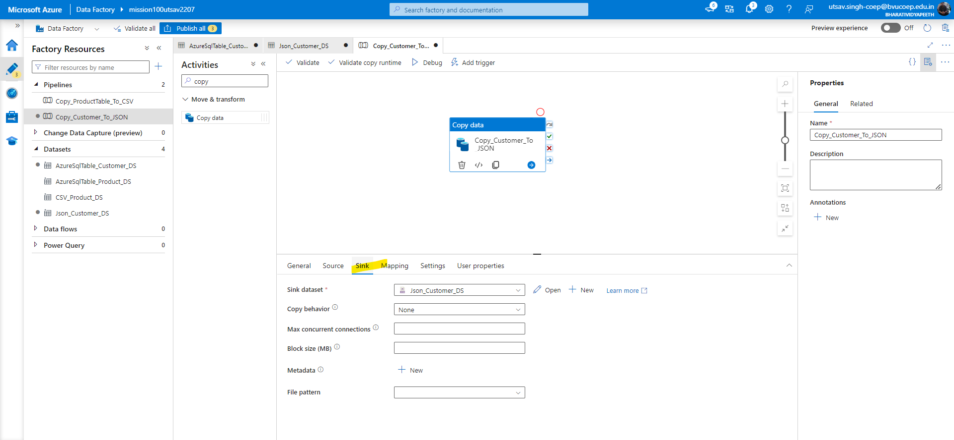

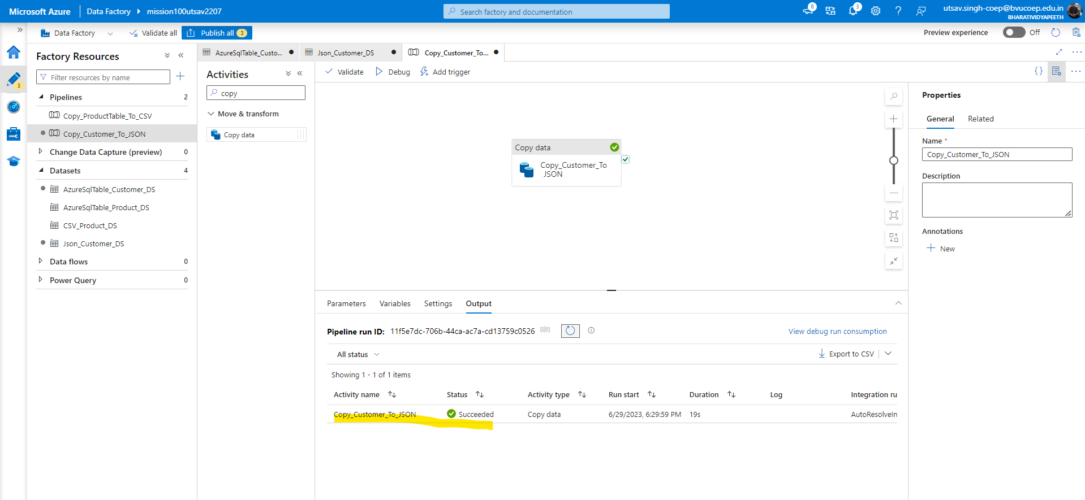

4. Check the ADLS in given path

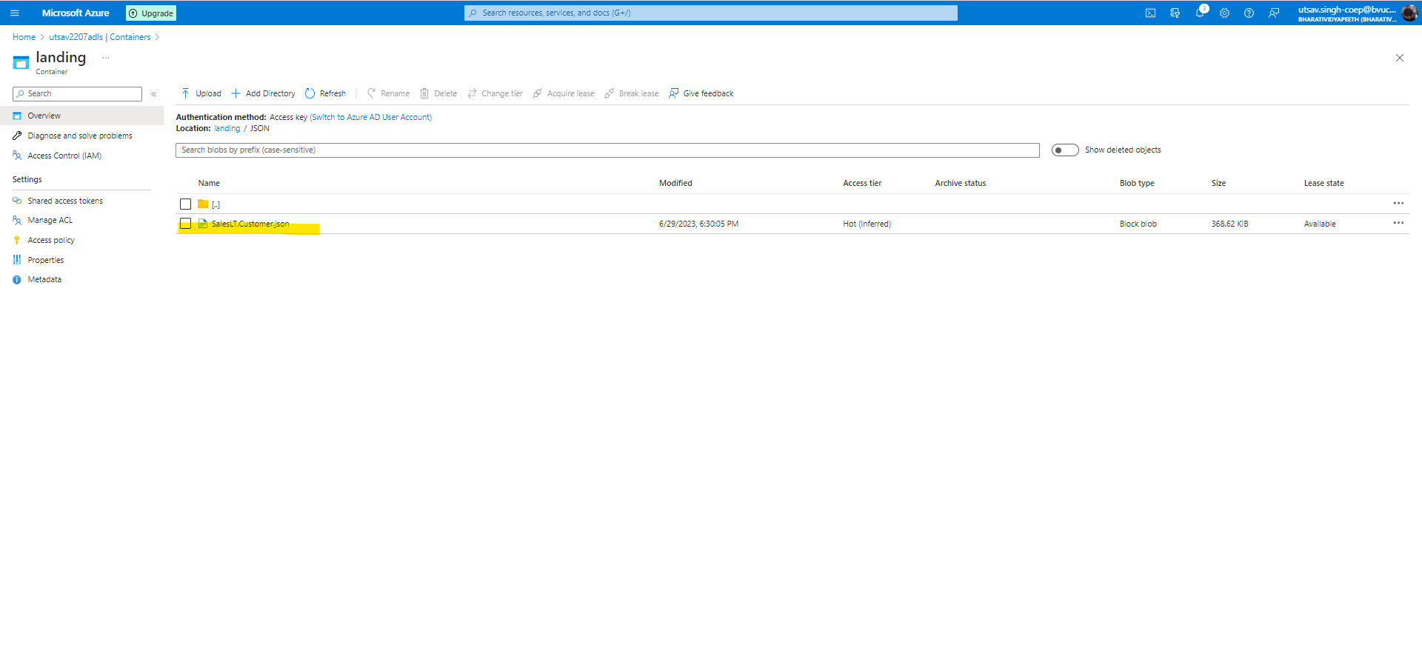

## **Question 3:**

## Create another pipeline name: Copy_Customer_JSON_To_Folder. In the last pipeline 1, you have created the Customer file in ADLS 'landing/CSV' folder. Now this time try to move this file to another ADLS folder 'landing/CSV2' using the ADF pipeline.

## 

## Hint: This time our source is ADLS 'landing/CSV' folder and destination is also of ADLS type but different folder 'landing/CSV2' (You can create one more dataset)

Solution:-

1.Create a new folder in landing as CSV2

-Generally we have to do transfer of data FROM ADLS TO ADLS As we have already CUSTOMER ADLS DATASET. So, this time we will create another destination Dataset with different path CSV2

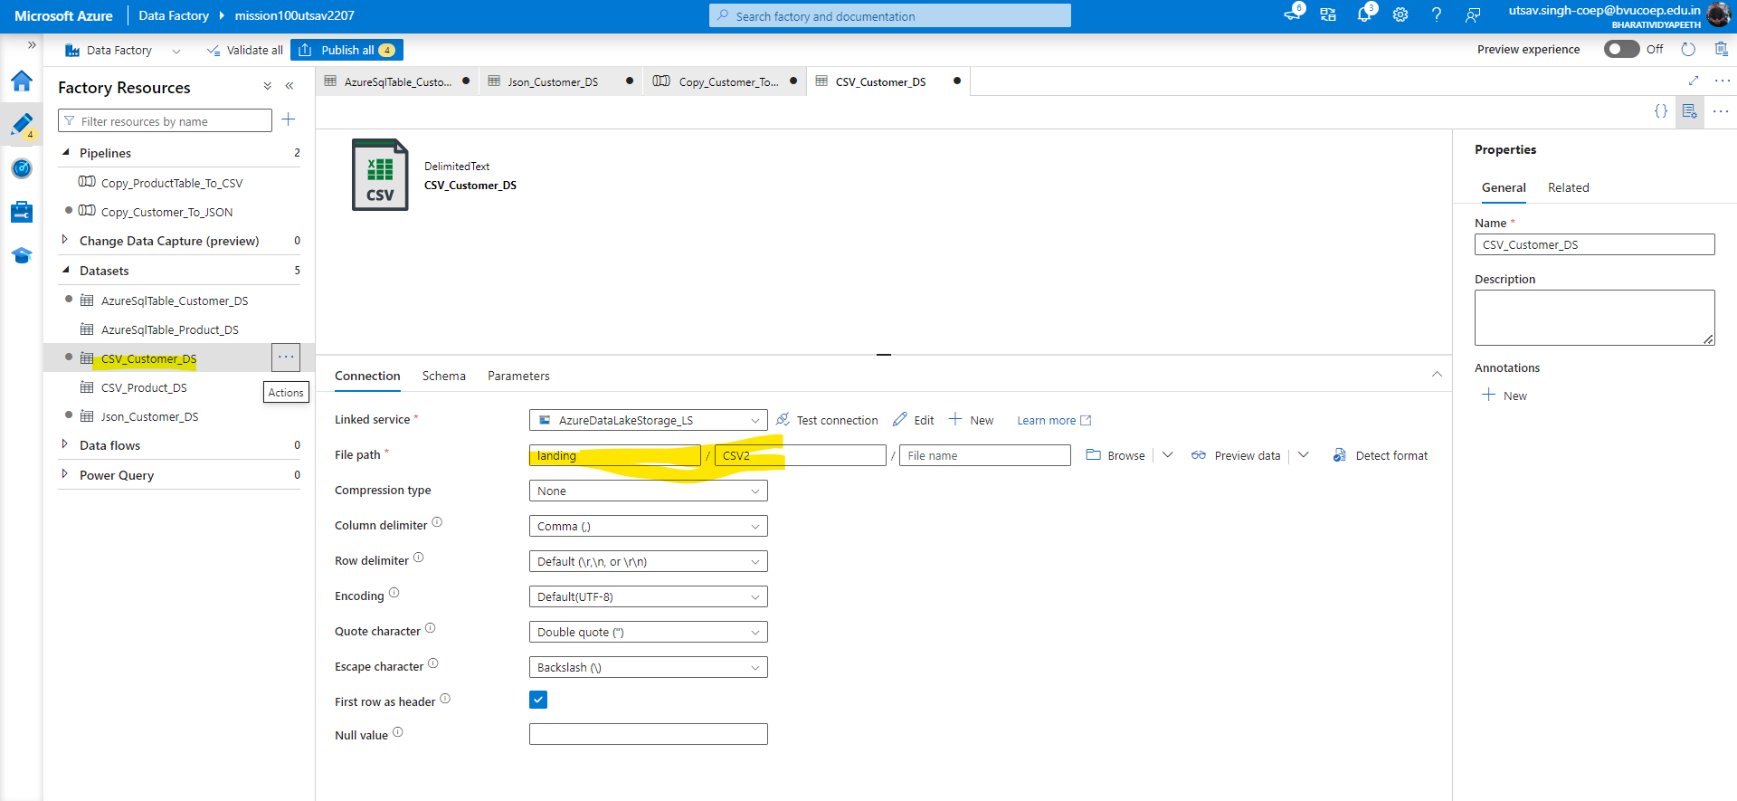

2.Now Create a new Pipeline to copy data from one ADLS path to another

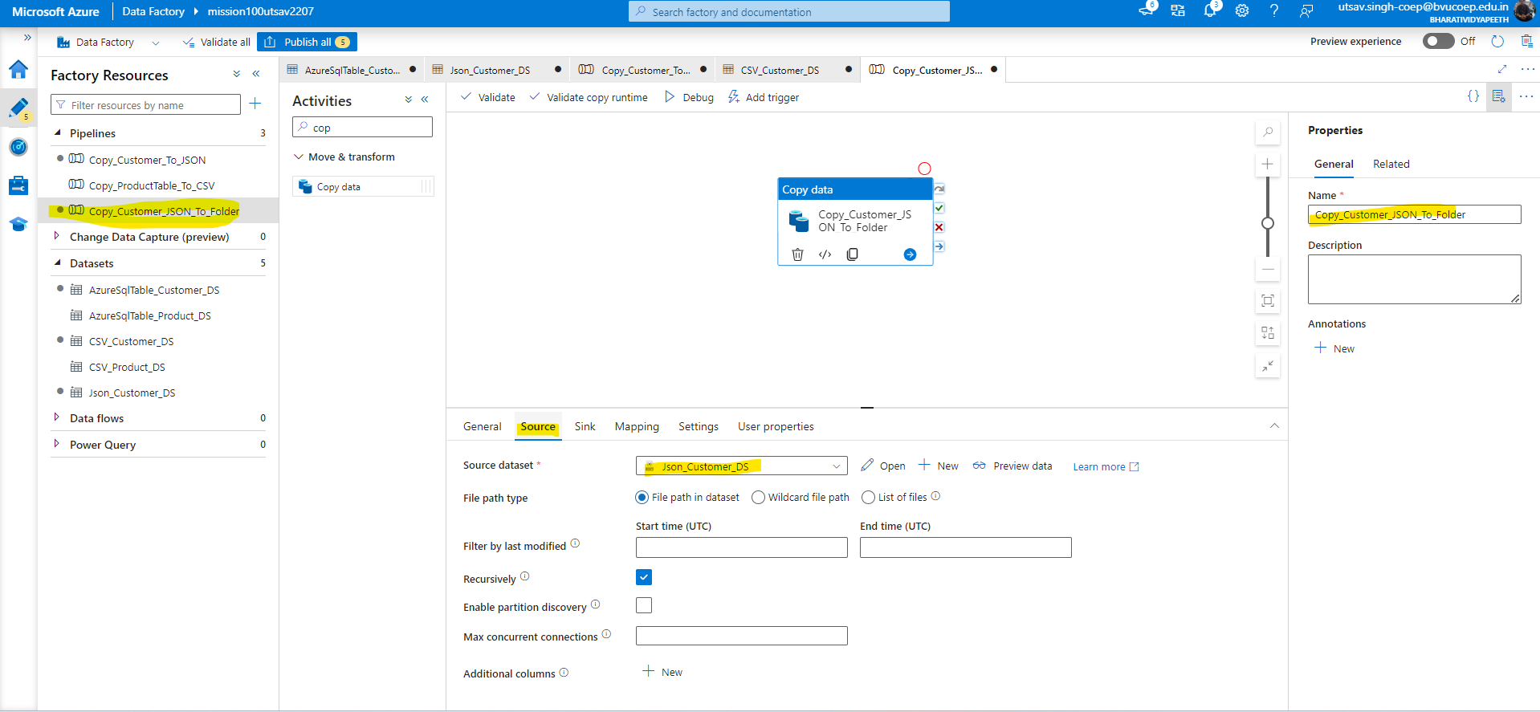

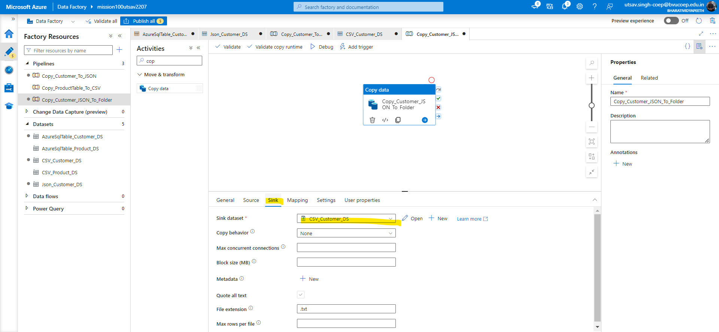

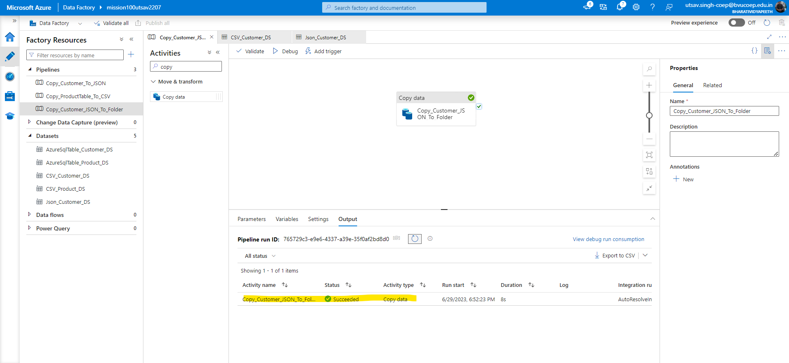

3. Now check whether that file is move to different location or not

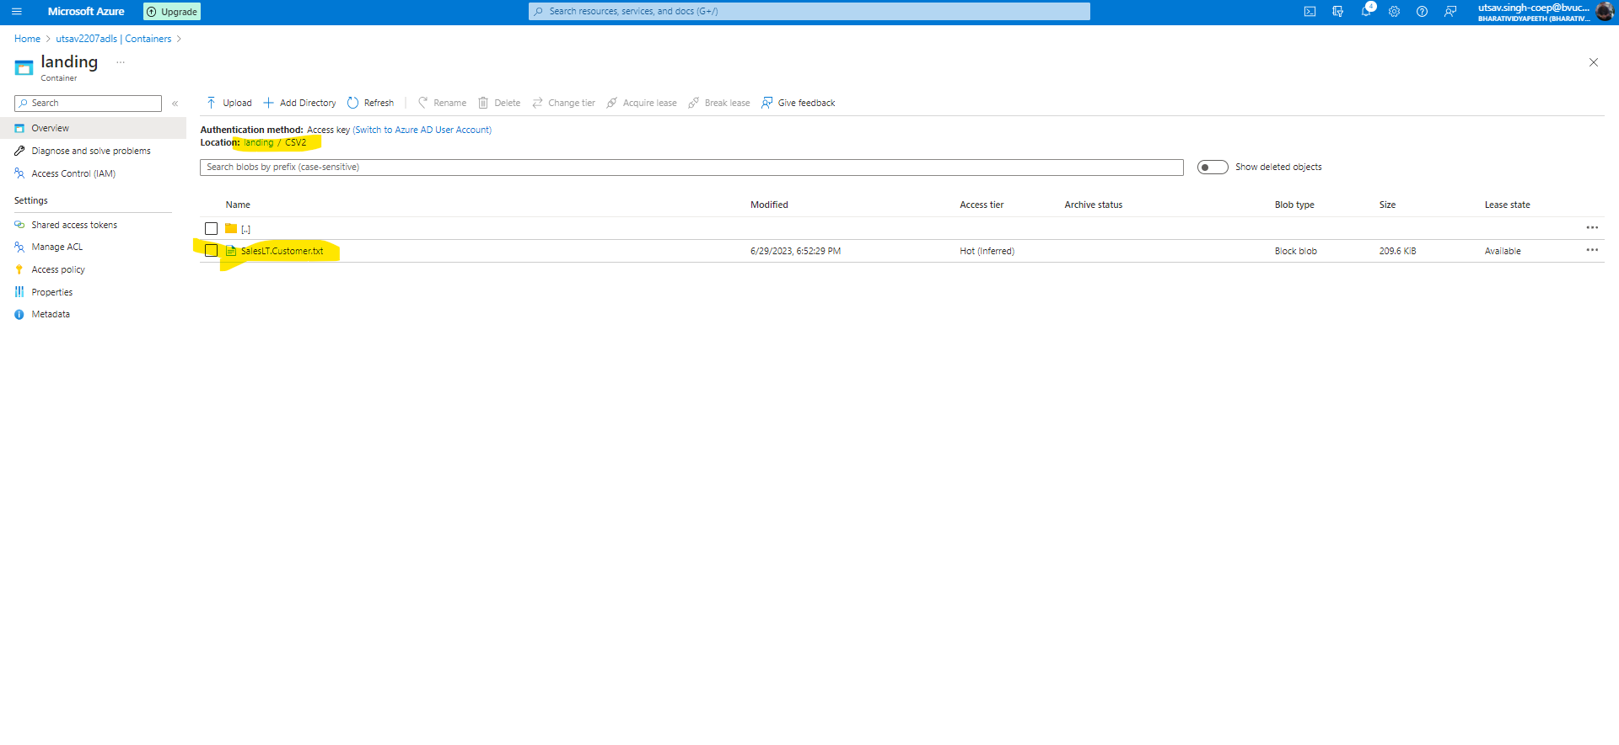

## **Question 4:**

## Create another pipeline name: Copy_Customer_To_CSV_Pipe In the newly created SQL DB there is one built in SalesLt.Customer table.

## Copy the Customer table data to CSV file in 'landing/CSV_Pipe' folder in ADLS using the ADF. But ensure that the delimiter of this file should be (|) instead of (,)

## Hint : After you create your dataset for CSV, open the dataset there you should see the option to change the delimiter.

**Solution:-**

1. Already we have created linked list and Dataset. Now we have to create another Dataset with different path and change the delimiter.

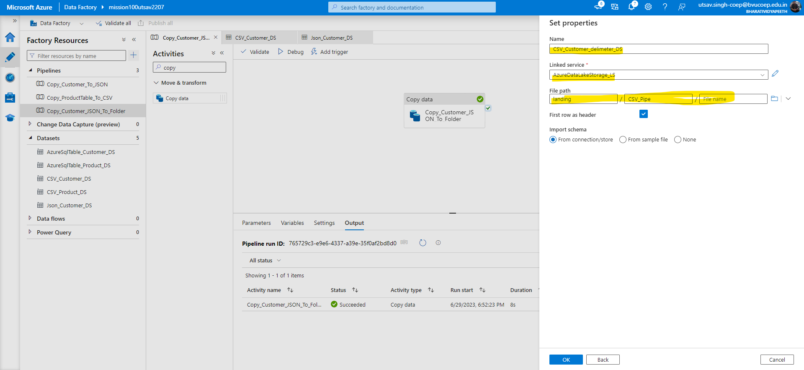

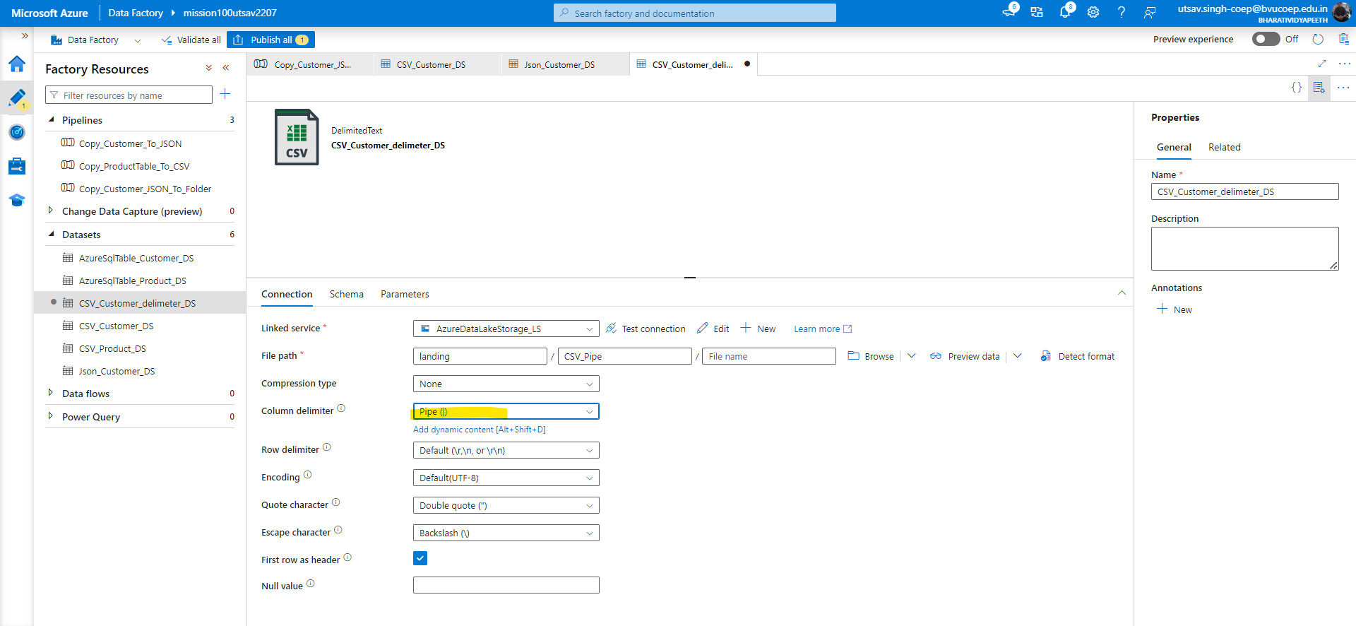

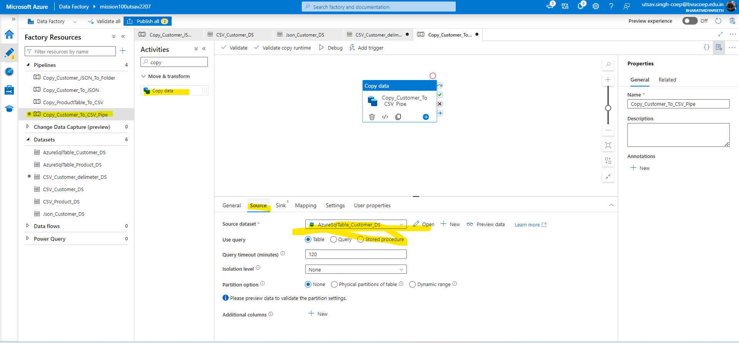

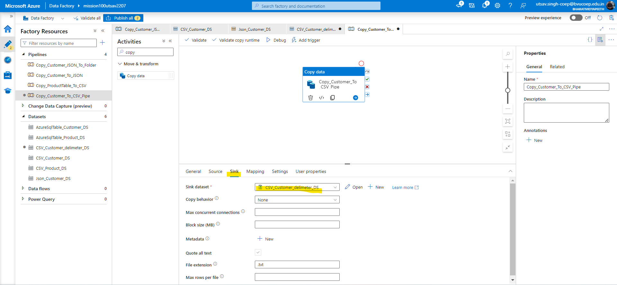

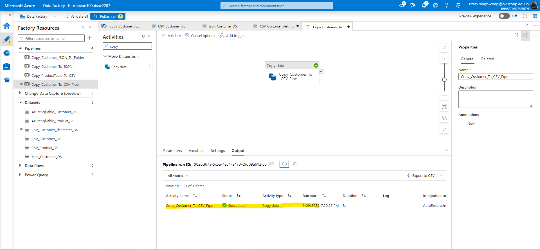

1. Check the file path whether file is generated in the given path or not and check delimiter too.

